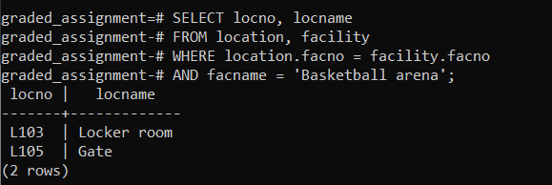

SELECT locno, locname

FROM location, facility

WHERE location.facno = facility.facno

AND facname = 'Basketball arena';